Lumina Advisory Website Content

1. HOME

Headline
Where ambition meets intentional growth.

Subheading
Lumina Advisory is a growth-focused consultancy supporting individuals and organisations through career growth, strategic advisory, leadership development, facilitation, and meaningful transformation.

CTA Buttons
- Book a free discovery call (WhatsApp)
- Work With Us (leads to email)
- Join the Community (leads to WhatsApp community)

Short Introduction
At Lumina Advisory, we believe growth should be intentional. Whether you are navigating your career, developing as a leader, building confidence, or creating high-performing teams, Lumina exists to support growth that is both practical and impactful.
We combine strategic insight, professional experience, and people-centred development to create spaces that inspire transformation personally and professionally.

Key Focus Areas
- Career & Personal Development
- Training & Skills Development
- Programme Direction, Moderation & Hosting
- Independent Consultanting & Advisory
- Strategic Facilitation & Team Alignment
- Leadership Development

2. ABOUT

Who we are
Lumina Advisory, founded in 2024 is a Level 1 BBBEE boutique advisory and development consultancy focused on people development, strategic facilitation, leadership, and organisational growth.
We partner with corporates, professionals, and emerging leaders to provide strategic advisory, leadership development, facilitation, and capability-building interventions that drive meaningful transformation and sustainable growth.
Our work combines strategic insight, practical industry experience, and people-centred development to create solutions that are both intentional and results-driven.
We provide services across independent consulting and advisory, strategic facilitation, leadership development, training and skills development, career and personal development, as well as programme direction, moderation, and hosting.
Through every engagement, Lumina Advisory aims to create spaces that inspire growth, strengthen leadership, and empower individuals and organisations to perform with clarity, confidence, and purpose.
Our Mission
To create transformative development experiences that empower individuals and organisations to grow with clarity, confidence, and purpose.

Our Vision
To become a trusted partner for career, leadership, and personal development across Africa and beyond.

Our Founder
Yolandi Pietersen is a consultant, facilitator, leadership development professional, and entrepreneur with a passion for helping individuals and organisations unlock their full potential.
With a career spanning management consulting, banking, leadership development, and strategic transformation, Yolandi brings a unique combination of corporate expertise and people-centred development to every engagement. Throughout her career, she has advised organisations across the public and private sectors on strategy, transformation, organisational effectiveness, leadership development, digital transformation, and business growth initiatives.
Yolandi holds an MBA, which she completed Cum Laude. Her academic achievements, combined with practical industry experience, have shaped her belief that meaningful growth happens when strategy, leadership, and personal development come together.
As the founder of Lumina Advisory, Yolandi is committed to creating transformative development experiences that empower professionals, leaders, and organisations to grow with clarity, confidence, and purpose. Through facilitation, training, coaching, and thought leadership, she aims to inspire intentional growth and lasting impact.
Her mission is simple. To help people become the most confident, capable, and purposeful versions of themselves.
(Insert Photo)
Yolandi Pietersen (MBA Cum Laude)
Founder & Managing Director

3. SERVICES

Career & Personal Development
Supporting individuals in navigating growth intentionally both personally and professionally.

Services Include:
- Career strategy sessions
- Personal development coaching
- Confidence and growth workshops
- Professional development support

Training & Skills Development
Delivering engaging and practical learning experiences designed for growth and capability building.

Services Include:
- Training programmes
- Graduate development sessions
- Skills development workshops
- Early-career professional programmes

Programme Direction, Moderation & Hosting
Professional moderation and facilitation for impactful events and conversations.

Services Include:
- Corporate events (Speaker, Host & Programme Director)
- Panel discussions
- Conferences
- Internal broadcasts and hosting

Independent Consulting & Advisory
Providing strategic consulting and advisory support to organisations.
Services Include:
- Strategy advisory
- Programme and project support
- Business transformation
- People advisory
- Customer experience improvement
- Product development
- Stakeholder engagement
- Change and implementation support

Strategic Facilitation
Facilitating impactful conversations that drive alignment, clarity, collaboration, and team effectiveness.

Services Include:
- Leadership alignment sessions
- Strategy workshops
- Team effectiveness facilitation

Leadership Development
Developing confident, self-aware, and high-performing leaders.

Services Include:
- Leadership workshops
- Women in leadership sessions
- High-performance team development
- Organisational culture conversations

4. COMMUNITY

Join the Lumina Community
The Lumina Personal Development Community is a growth-focused space for ambitious individuals committed to becoming the next version of themselves.
This community was created to support personal and professional growth through meaningful conversations, shared experiences, practical resources, and intentional development.

What You Can Expect
- Career development conversations
- Live coaching and advice webinar sessions
- Leadership and confidence-building discussions
- Networking and community engagement
- Reflection prompts and growth resources
- Practical tools for intentional growth

Upcoming Events
xxx

CTA
Join the Community (link to WhatsApp community)

5. WHAT PEOPLE ARE SAYING
"Yolandi helped me see my career from a completely different perspective. I left our session with clarity, confidence, and a practical action plan for my next steps." — Career Coaching Client
"The session was professionally facilitated, highly engaging, and left the team with clear outcomes and next steps. A truly valuable experience." — Corporate Workshop Client
"The interview preparation session was incredibly valuable. I felt more prepared, more confident, and ultimately performed much better than I would have on my own." — Young Professional
"Yolandi brings energy, professionalism, and authenticity to every engagement. She connects with audiences in a way that inspires action." — Event Attendee
"Being part of the Lumina community has reminded me that growth doesn't have to happen alone. The conversations, resources, and support have been invaluable." — Community Member
Why Work With Lumina
Consulting Expertise: Drawing on experience across management consulting, banking, transformation, and organisational development.
Practical Solutions: Providing recommendations that are actionable, measurable, and aligned to organisational goals.
People-Centered Approach: Combining strategy and human insight to create sustainable outcomes.

6. ARTICLES

XXX

7. CONTACT

Let’s Connect
Whether you are looking for a facilitator, speaker, coach, moderator, or development partner, we would love to hear from you.
073 296 0488
info@luminalegacy.co.za
Johannesburg, South Africa

Interactive Contact Form

Form Fields
- Full Name
- Email Address
- Contact Number
- Tell us more about your request
(Text Box)

Socials
LinkedIn:
Email Contact

Closing Line
Growth starts with one intentional step. Let’s build something meaningful together.

Look & Feel
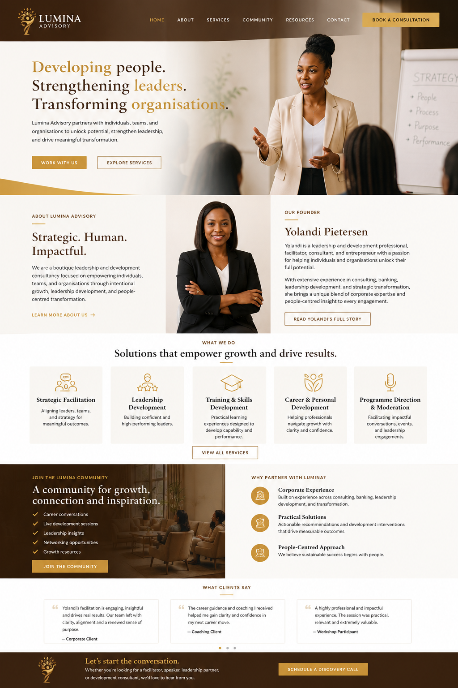
Overall Brand Feel
- Premium
- Strategic
- Modern
- Executive
- Human-Centred
- Transformational
- African Excellence
- Sophisticated
Photography Style
Use:
- Workshop facilitation
- Leadership discussions
- Diverse professionals
- Executive coaching
- Team collaboration
- Modern office environments
Examples from Pexel





Website:
https://www.emzadvisory.com/

